CADKEY WorkshopV20 Tutorial - File Referencing

Step 1 Familiarize yourself with the interface

Before you start the tutorial, take some time to familiarize yourself with the various parts of the CADKEY WorkshopV20(CKWSV20) interface. You’ll be instructed to access commands from different parts of the interface throughout this tutorial. Refer back to this image if you get lost. You’ll also be instructed to use several “hot-keys” to access commands as well. Keep in mind that the CKWSV20 interface is very versatile and customizable. Commands can be accessed through different parts of the interface depending on your personal preference

Step 2 Load a file to start the tutorial

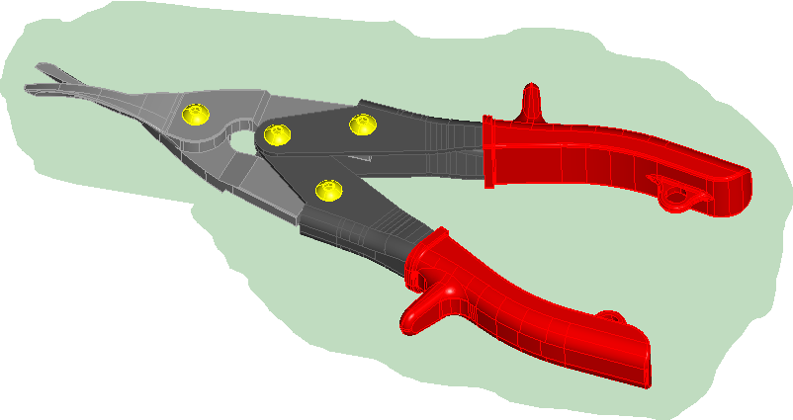
This tutorial will guide you through the steps needed to “assemble” some of the components of the tin snips shown above using CKWSV20’s new file referencing features. During this process you’ll be exposed to many of the new features and functions found in CKWSV20. Each component of the tin snips (jaws, handles, fasteners) has been created as a solid model using CKWSV20’s solid modeling tools and saved in the Workshop20/CKD directory that was loaded when you installed CKWSV20. Using windows explorer, take a minute to locate that directory on your hard drive. With CKWSV20 running, open the file start_tin _snips_assy. ckd. To do that choose FILE>OPEN from the windows pull-down menus. Browse for the file and load it as you would in any other windows application.

Step 3 Build a custom toolbar  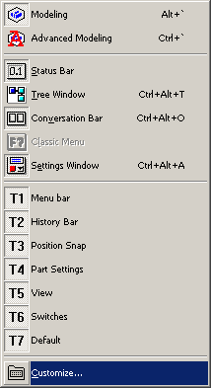 | 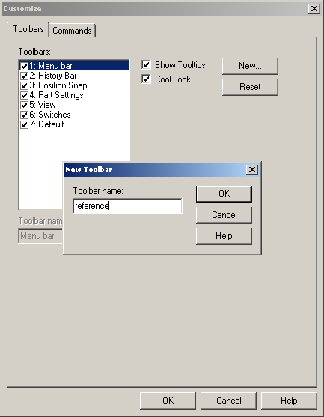
Before you start to actually build the tin snips assembly model, it would be a good idea to build a customized “file referencing “ toolbar. You’ll be able to access the file referencing command very easily using this tool bar. Start by right-clicking the mouse anywhere in the CKWSV20 drawing area. The TOOLBAR MENU (used to toggle on and off toolbars) will pop up under the cursor. From the toolbar menu choose CUSTOMIZE. Next the CUSTOMIZE DIALOG BOX will pop up. Select the TOOLBAR tab, then choose the NEW button to create a new toolbar. You’ll be prompted to name the new toolbar, so input the name “REFERENCE” and choose OK

You’ve just created a new toolbar called “REFERENCE”. The tool bar should be floating near the left hand edge of your CKWSV20 interface. You can drag it about the interface by left clicking and dragging it with the mouse. Next, you’ll need to populate your new toolbar with the icons that you’ll need to access the file referencing commands. Start by choosing the COMMANDS tab in the CUSTOMIZE DIALOG BOX, then scroll through the CATEGORIES list, then find and click on ASSEMBLIES. The file referencing icons will be displayed in the BUTTONS area to the right of the CATEGORIES list. Left-click and drag each of the icons on to your newly created tool bar. When you’ve finished populating the toolbar choose OK in the CUSTOMIZE DIALOG BOX to end your customization session. You should now have a customized “REFERENCE” toolbar like the one shown below. | 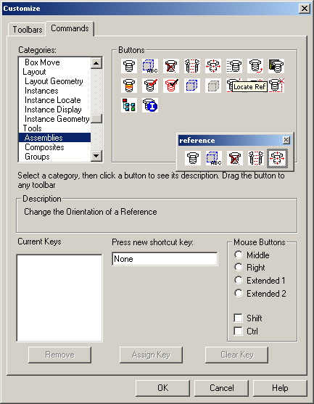
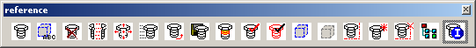

You can dock toolbars horizontally and vertically about the CKWSV20 interface. Left click on the bar at the top of your new tool bar then drag and dock it vertically at the right hand side of the interface.

Step 4 Save a Workspace

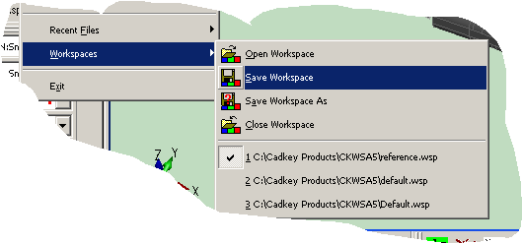

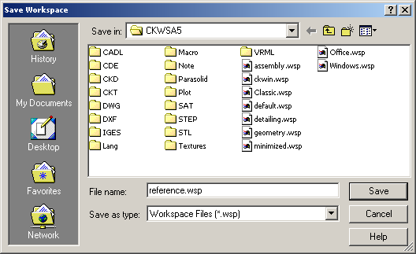
The current collection of toolbars and their orientation about the interface can be saved at any time using a WORKSPACE (.wsp) file. CKWSV20 ships with several customized .wsp files. Workspaces can be customized to make the relevant commands for the task at hand readily available through the tool bar portion of the CKWSV20 interface. We’ve just created a toolbar for file referencing commands. It would be just as easy to set up the interface for detail drawing operations or solid modeling, then save that workspace and reload it when you needed that specific set of commands. To save your newly created workspace choose FILE>WORKSPACE>SAVE from the windows pull-down menu. In the SAVE WORKSPACE DIALOG BOX input the name “REFERENCE” and choose SAVE. Now, try opening some of the pre-saved workspace files, which were installed with CKWSV20, to see the affect that changing the workspace has on the interface. Use FILE>WORKSPACE>OPEN from the windows pull-down menu When you’ve finished experimenting , open your saved REFERENCE.wsp.

Step 4 Set up the level list

CKWSV20 has all new level list functionality. Levels can be used to organize design files by allowing the user to add or remove displayed data from the drawing area. As you build the tin snips assembly, you will place data on different levels and add or remove data from the display as needed by toggling the display status for a specific level. The level list expands and collapses from the left hand side of the drawing area. To expand the level list hold down the ALT key and press the RIGHT ARROW KEY. Doing this once will expand the list to what is called the PART SPLITTER which is the moveable right hand edge of the level list. Pressing ALT and RIGHT ARROW a second time will expand the list completely. You can also collapse the list using ALT and the LEFT ARROW. Use the ALT and RIGHT ARROW keys to expand the list to the PART SPLITTER

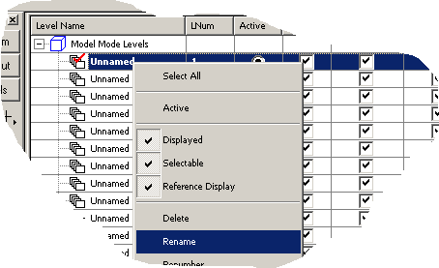
CKWSV20 can have an unlimited amount of levels and nested sub-levels. For this tutorial you‘ll use the first three levels in the list. RENAME the first three levels one at a time by right clicking on the specific level to access the LEVEL COMMAND drop down menu. Choose RENAME, then type in the new name for the level and press ENTER to accept the new name.

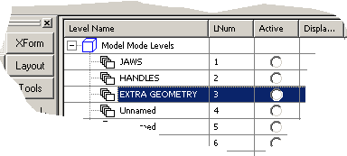
Name the first three levels JAWS, HANDLES, and EXTRA GEOMETRY respectively. Your new level list should look like the one shown above.

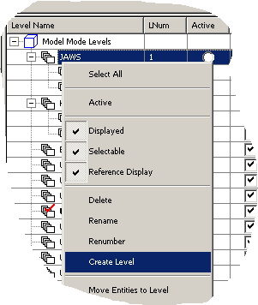
Next create two sub-levels under the JAWS and HANDLES levels. To do that right click on the level, then choose CREATE LEVEL from the LEVEL COMMAND drop down menu. Repeat this procedure to create a second sublevel for each. RENAME the newly created sub levels as shown above.

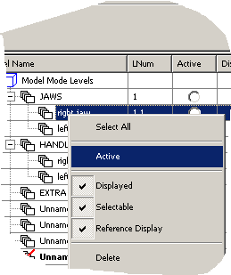 | 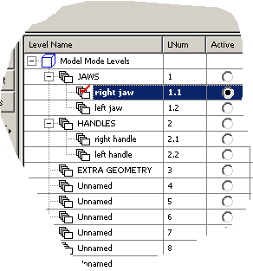
When you create geometry, it is automatically placed on the ACTIVE level. Any level can be set to be the ACTIVE level, but there can only be one ACTIVE level at a time. Make the RIGHT JAW sub level the ACTIVE level by right clicking on the level and choosing ACTIVE from the level command drop down menu. The ACTIVE LEVEL is denoted with a red check.

As you build the assembly, you’ll want to have the level list open. It was mention earlier that the PART SPLITTER was moveable. Left-click grab and drag the PART SPLITTER to the left so that only the level names are in view, as shown above. With the PART SPLITTER in this position you’ll be able to access the level list while maintaining a large drawing area.

Step 5 Placing a part reference | 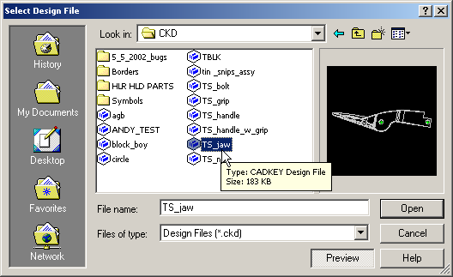

The first reference to place is one of the tin snip jaws. To do that you’ll need to reference the file TS_jaw.ckd. Select the CREATE REF icon from the reference tool bar that you crated earlier. In the SELECT DESIGN FILE dialog box choose the file TS_jaw, then choose OPEN.

In the CREATING A NEW PART REFERENCE dialog box . Set up the options as shown to the left.

Associativity options allow you to “associate” the position, rotation, and orientation of a part reference with other positions on geometry within a file. For instance, if you associate the position of a part reference with the center of an arc and for some reason the position of the arc changes. The position of the referenced part would also change maintaining the “associative position” relationship between the referenced part and the arc. Simply put, the associativity options allow you to create positional relationships between the various components of an assembly.
Also, the insertion plane options allow you to orient your part reference with the current construction plane or an existing plane entity. For this tutorial you’ll orient all of the references using the construction plane. You can refer back to Step 1 to find the CONSTRUCTION PLANE AXIS INDICATOR. Viewing this indicator and the thumbnail preview of the part that could be seen in CREATING A NEW PART REFERENCE dialog box will give you an idea of how the reference will be oriented. Just match the view that you see in the thumbnail with the X-Y plane shown on the CONSTRUCTION PLANE AXIS INDICATOR.

Once you’ve set up the dialog as shown choose OK.

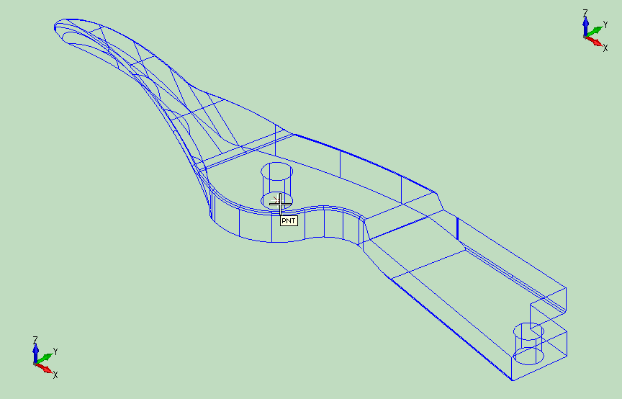
Once you’ve chosen OK, move the cursor near the point (PNT) entity at the center of the drawing area. The POSITION SNAP mechanism will indicate, with a tool tip, that you have snapped to the point. Once you see the PNT tool tip, left click the mouse to place the reference of the jaw. Type CTRL-A to auto scale the part so that you can view it easily. AUTOSCALE adjusts the zoom so that you can see all of the displayed geometry in the file. Also, AUTOSCALE is an immediate mode command. To execute an immediate mode commands you do not need to exit the current function.

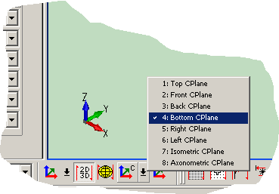 | 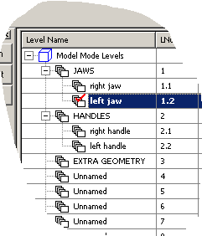
The CREATE REFERENCE tool is modal, which means that you don’t exit the command until you hit ESCAPE. Therefore, you can place multiple references of the same part without exiting the CREATE REFERENCE command. Now, you can place a second reference of the jaw. You need to execute two immediate mode commands before you do that. Since the orientation of the second jaw will be different from that of the first, change the CONSTRUCTION PLANE by clicking on the CPLANE icon in the lower left hand corner of the interface. Choose BOTTOM CPLANE from the pop up list. You’ll see the CONSTRUCTION PLANE AXIS INDICATOR CHANGE accordingly. Next, since you’ll be placing the left jaw, you’ll need to make the LEFT JAW level active. Right-click on the LEFT JAW level in the level list and choose ACTIVE from the pop up menu.

Move the cursor near the point entity at the center of the drawing area. The POSITION SNAP mechanism will indicate, with a tool tip, that you have snapped to the point. Once you see the PNT tool tip, left click the mouse to place the reference of the jaw. Choose ESCAPE to exit the CREATE REFERENCE command. You place two references of the same part to represent the two jaws of the tin snips. You placed them using the ASSOCIATIVE POSITION option, therefore the two references are “associated” with the point entity that you used to place them. Think of the point as an anchor point. You’ll now be able to rotate each of the jaws about that point simulating the true rotating motion of the mechanism. This will become evident in the next step, where you will adjust the rotation of each jaw.

You’ve been viewing the model from the ISOMETRIC view. Change the view to the TOP VIEW by pressing ALT+V (this is the hot key combination for view change). On the CONVERSATION BAR mouse select LIST and choose TOP VIEW from the pop up menu. Next, use CTRL+A to AUTOSCALE, then change the CONSTRUCTION PLANE to TOP CPLANE using the CPLANE icon found in the lower left hand corner of the interface. Also make the EXTRA GEOMETRY level ACTIVE by right clicking on the EXTRA GEOMETRY level in the level list and choosing ACTIVE.

Step 6 Adjust the rotation of a part reference

Next, you need to adjust the rotation of the references that you’ve placed. To do that you’ll need to create some additional geometry. Create the arc shown above by pressing the A key (hot key for the arc commands). The ARC PALETTE will pop up under the cursor. Choose CREATE ARC BY SPECIFYING THE CENTER AND EDGE. Watch the conversation bar for prompts once you execute the command. Enter a start angle of 315 and an end angle of 45. The position snap mechanism will help you to choose the center and edge of the arc. Mouse select the point (PNT) entity shown above to define the center of the arc, then select the center (CTR) of the hole shown above to define the edge of the arc.
When you try to select the center of the hole, the position snap will most likely try to snap to other positions near the cursor. Toggle through the positions using the SPACE BAR. When the tool tip for the center of the hole (CTR) is displayed mouse click to select the position.

Next, place equally spaced points along the arc that you’ve just crated in 5-degree increments. The arc that you made sweeps through 90 degrees, so you’ll need 90/5 or 18 points. To generate the points press the P key (hot key for the point palette). Select the icon for CREATE A SPECIFIED NUMBER OF POINTS ALONG A CURVE. On the CONVERSATION BAR enter 18 as the number of segments on the curve, then mouse select the arc you created earlier.

Now you can adjust the rotation of the jaws. Remember you placed the jaws with an associative position, so the jaws will rotate about that point. Select the ROTATE REFERENCE icon from the tool bar that you created. Watch the CONVERSATION BAR. When you’re prompted to select the reference to change move the cursor over the jaw that you’d like to rotate. When the appropriate jaw highlights, mouse select it. Next, move the cursor near the points that you created. The position snap will snap to the point (PNT) entities. Select the 15-degree point to rotate the appropriate reference into position. Repeat this procedure to rotate the second jaw into position. Using this method you could analyze the position of the jaws at various rotation angles, simulating the actual motion of the tin snips in use.

Step 7 Create a reference for the tin snip handles

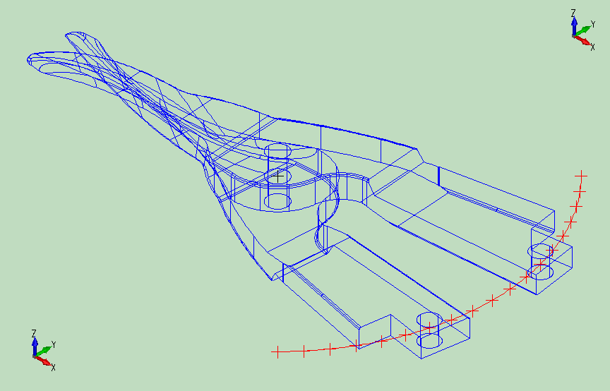

Next you’ll place a reference for the two handles of the tin snips assembly. Change back to the ISOMETRIC VIEW. Type ALT+V, then choose LIST from the CONVERSATION BAR and select ISOMETRIC VIEW from the pop up menu. You should still be in CPLANE1, but you’ll need RESET the ACTIVE level to the RIGHT HANDLE level.

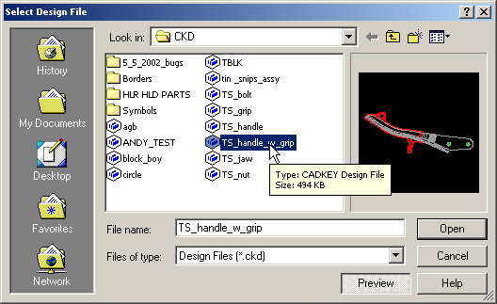
Next, place a reference of the file TS_handle_w_grip.ckd. Select the CREATE REF icon from the reference tool bar that you crated earlier. In the SELECT DESIGN FILE dialog box, choose the file TS_handle_w_grip, then choose OPEN.

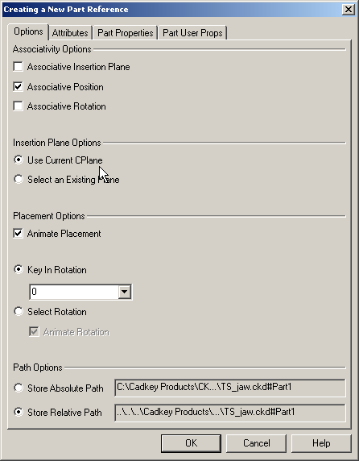 | In the CREATING A NEW PART REFERENCE dialog box. Set up the options as shown to the left.
Next, position the reference by choosing DELTA from the CONVERSATION BAR. When you prompted to indicate the DELTA ORIGIN, use position snap to select the center (CTR) of the circle that is shown in the figure below. To do that, move the cursor near the circle. When you try to select the circle center, the position snap will most likely try to snap to other positions near the cursor. Toggle through the positions using the SPACE BAR. When the tool tip for the center (CTR) of the circle is displayed mouse click to select the position.

On the CONVERSATION BAR, enter the delta values dcX=0, dcY=0, dcZ=-1.5 to place the reference. Remember the CREATE REFERENCE command is model, change the CPLANE to BOTTOM CPLANE and make the LEFT HANDLE level ACTIVE. Now, you can place a second handle reference.

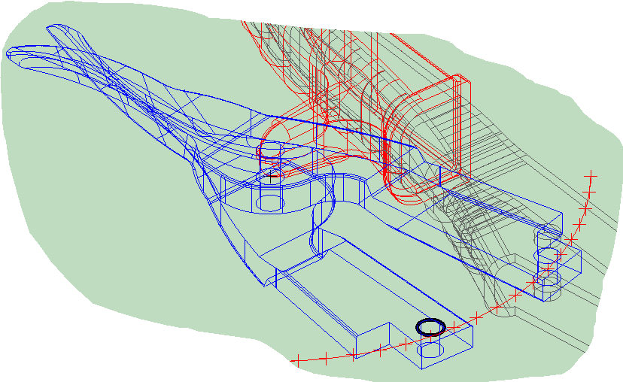
Choose the center (CTR) of the circle shown above as the DELTA REFERENCE. On the CONVERSATION BAR, enter the delta values dcX=0, dcY=0, dcZ=-2.5 to place the second handle reference. Use ALT+V (view change hotkey) and choose LIST from the CONVERSATION BAR, the, TOP VIEW from the POP UP menu to change to the TOP VIEW. Change the CPLANE to the TOP CPLANE.

Step 8 Adjust the rotation of the handle references

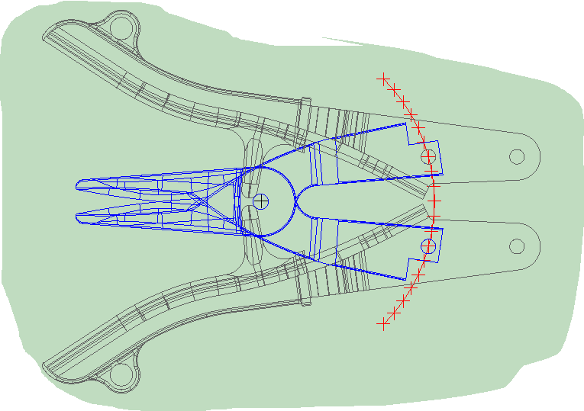
Obviously you’ll need to adjust the rotation of the two references that you’ve just placed. You’ll need to create some additional geometry to do that. Make the EXTRA GEOMETRY level ACTIVE. Press the C key (hotkey for circle palette), then choose CREATE CIRCLE BY SPECIFYING THE CENTER AND AN EDGE from the circle palette.

Generate the two circles shown above. Use the points (PNT) shown to define the centers and the centers (CTR) of the holes shown to define the edges. Watch the CONVERSATION BAR for prompts and remember that the CREATE CIRCLE commands are modal. Move the cursor near the positions that you need to select. Position snap will help you to select the positions. Use the space bar to toggle to the position that you need if necessary.

To adjust the rotation of the two handle references choose the ROTATE RFERENCE icon from the REFERENCE tool bar. When prompted to select the reference to change, select one of the handles, then, choose INTRSCT from the CONVERSATION BAR. Mouse select the two circles that you just created near the intersection shown to adjust the reference. The command is modal, so repeat the process to adjust the second reference.

Step 9 Render and view the model
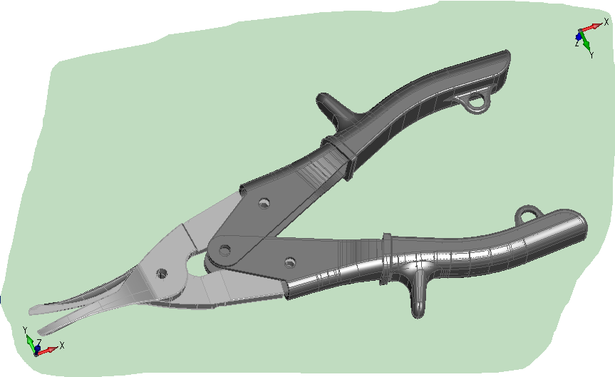
Right-click on the EXTRA GEOMETRY level in the level list and toggle OFF the display attribute on the pop up menu to hide the extra geometry that you’ve created. To view your newly created assembly as a rendered model press SHIFT+5 (hot key for SMOOTH SHADED render mode). If you’d like to DYNAMICALLY ROTATE the view press ALT+SHFT+V (hotkey for DYNAMIC ROTATE), then left click and drag the cursor across the drawing area to rotate the model. Choose ESCAPE to exit the command. Use ALT+V to return to the TOP VIEW and SHIFT+1 to return to WIREFRAME rendering. Also, display the EXTRA GEOMETRY level by right clicking on the EXTRA GEOMETRY level in the level list and toggling ON the display attribute.

Step 10 Analyze the range of motion for the assembly
Now that you have built the assembly of parts with associative relationships, you can experiment. To reposition the entire assembly, start by rotating each jaw to a new position. Use the ROTATE REFERENCE command to align each jaw with the 25-degree positions along the arc as shown above. Notice that the handles will move with the rotating jaws. That’s because when you placed the handle references, you used an associative position. Also notice that the handle rotations are incorrect because the rotations are associative with the intersection of the two circles. Repositioning the circles to align the circle centers with the 25-degree points along the arc will correct the problem. The next step will help you to do that.

To move the circles, you can use one of the great new tools in CKWSV20. It’s called GENERIC MOVE. Find and select the GENERIC MOVE icon near the top of your interface. Watch the CONVERSATION BAR. You’ll be prompted to select the entity to move. Move the cursor near one of the circles, then mouse select it. Next, you’ll be prompted to SELECT A BASE POSITION. The Base position is a reference point by which you will position the circle that you’ll move. POSITION SNAP will help you to select the center (CTR) of the circle. Finally, you’ll need to define the new BASE POSITION, which will be the 25-degree point along the arc. Move the cursor near the 25-degree point (PNT). POSITION SNAP will help you to select the point. The GENERIC MOVE command is modal, so you can repeat the process for the second circle without exiting the command. Once the circles have been moved you’ll see that the rotation of the handle will update accordingly.

You’ve investigated quite a few functions in this tutorial. You can find the files for the fasteners (NUTS <TS_nut.ckd> and BOLTS <TS_bolt.ckd>) for this assembly in the CKD directory where the other files for this tutorial were found. See if you can finish the assembly on your own.

Keep in mind that there are a number of file referencing related functions, like automatic exploded views and the ability to edit the parent file of a reference and have any references to that file update automatically, that were not covered in this tutorial. You can refer to our website www.cadkey.com for more tutorials and instructional videos that can help you to understand all of the new functionality that can be found in CADKEY Workshop V20.

